The God Who Speaks

The Year of the Word
30th September 2019 - 31st December 2020

‘celebrating, living and sharing God's word’

The Catholic Bishops’ Conference of England and Wales have designated 2020 as 'The God Who Speaks': A Year of the Word to celebrate the 10th anniversary of Verbum Domini - Pope Benedict XVI’s Apostolic Exhortation on ‘The Word of the Lord’, and the 1600th anniversary of death of St Jerome, who translated the Bible into Latin.’ In keeping with the Church’s three year cycle there will also be a specific focus on St Matthew’s Gospel.

For more information please visit:
http://www.cbcew.org.uk/home/events/the-god-who-speaks/
or
https://rcdow.org.uk/faith/2020-year-of-the-word-the-god-who-speaks/
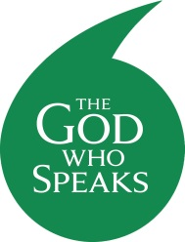
Official Prayer
Living God,
you walk alongside us
and speak to us throughout the Scriptures.
Your Son, Jesus Christ,
listens to our hopes and fears
and shows us how to live for one another.
Send us the Holy Spirit
to open our hearts and minds
so that we may be your witnesses throughout the world.
Amen
V. Your word is our path and your truth is our light.
R. This day and every day.
Our Lady of the Annunciation Pray for us
St Matthew Pray for us
St Jerome Pray for us

