Frequently Asked Questions:
How do you rank applications?
Our admissions criteria are set out in our Admissions Policy, which can be found at the top right of our website.
My child is a Baptised Catholic, do you also need a Certificate of Catholic Practice (‘CCP’)?
No. We do not have a separate criteria for the CCP. If your child is Baptised, you will just need to provide their Baptism Certificate.
My child isn’t Catholic, will they still have a chance of getting a place?
Generally we are oversubscribed with applications from Catholic families. However, for our EYFS 2020-2021 and 2021-2022 cohorts we will be taking a double intake – this means we will have 60 spaces. As a result, it is highly likely that we will be allocating to non-Catholic families. This year is your best chance of getting your child into St Catherine’s.
Do you have WrapAround Care?
Yes. In normal, non-Covid times, we run Breakfast Club from 7.40am to the start of the school day and Afterschool Club to 6pm. Unlike most other schools, this does not need to be booked in advance and can be used on an ad-hoc basis.
My child is of a different faith to Catholicism. Will they have to take part in Catholic prayer/worship etc.?
We pride ourselves on being a very diverse, inclusive school. As well as having pupils with a broad range of ethnicities, we also have pupils of no faith, other Christian dominations and practicing Muslims and Hindus. Many of our Muslim and Hindu families are happy for their children to take part in Catholic worship. Children who aren’t are just respectfully silent throughout. We also ensure that we learn about other faiths and celebrate the richness of other faith traditions.

What makes St Catherine’s different to other schools?
There are many things which make St Catherine’s special and unique. Primarily, we are a family! We pride ourselves on providing a fully inclusive and nurturing environment for our pupils and the wider community. We regularly go over and above to ensure that St Catherine’s is a safe and welcoming place- just like a second home!
Our dedicated and skilled staff have vast experience in supporting children with a wide range of backgrounds, needs and talents and encouraging them to thrive in all areas of school life. We are passionate about sustainability and you will notice from looking at our website and on Twitter, that we try to limit the use of plastics and instead strive to re-cycle and reuse materials as much as we can. We only laminate when completely necessary and utilise reclaimed materials to make furniture and storage across the school. Our classrooms are calm and neutral spaces which provide a purposeful and tranquil learning environment.
We use our outdoor area as much as possible. We are a Forest School and have a school farm which is run by the pupils and small group of dedicated parents- the Farm Squad! We aim to give the children real and first-hand experiences whenever we can and have developed an engaging, skills based curriculum which is designed to motivate and challenge.
What if my child has additional needs, how will you support them?
At St Catherine’s, we celebrate the uniqueness of every individual and the child is at the centre of all that we do. Transition for children with additional needs often starts long before they arrive in September. The class teacher or SENCO will contact you in the Summer Term to discuss your child’s needs. We liaise closely with Nurseries and pre-schools to ensure that relevant information passed on so that support and provision can be put in place for their first day. We organise a personalised programme of transition which may involve home visits; visits to the classroom/nursery; photo books; child passports etc. We offer the option of a staggered start or reduced timetable if necessary. We have access to a range of specialist support services including Speech and Language therapists, Educational psychologists, Occupational therapists etc.
What is the uniform?
Please see the Uniform page on our website. Children come to school dressed in PE kit on their PE days. Our uniform policy is relaxed at the moment due to Covid.

How well do your pupils achieve academically?
St Catherine’s is a highly successful school. Of the 14 local Primary school St Catherine’s is jointly the highest for the percentage of pupils reaching the expected standard at KS2 in Reading Writing and Maths, (88%). In addition, our average progress score ranged from 0.1-2.9 (0 is expected National progress), with pupils achieving a positive progress score in every area and ‘Well above average’ in writing.
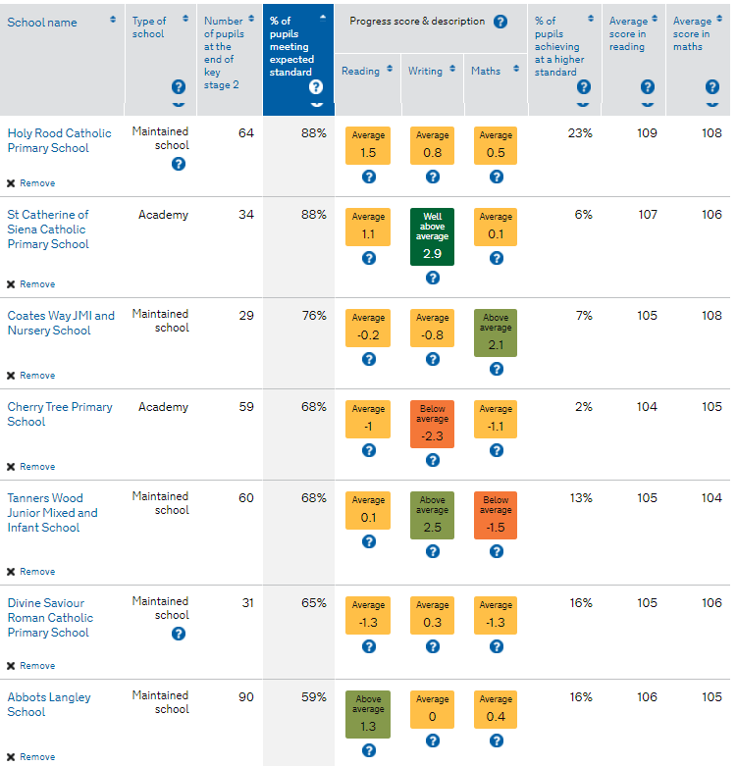
Do you take part in inter-school competition?
St Catherine’s established the Veritas league, a local inter-school competitive league made up of schools in our area. Our pupils compete in a range of sports such as: football, netball, Tag rugby, swimming and cricket. Currently this is hold due to Covid, however we cannot wait to fixtures up and running again as soon as we can.
What Secondary school do most of your pupils go to?
We are a main feeder school for St Michaels’ Catholic High School; the vast majority of our Year 6 pupils go there. We have strong links with the school (they are part of our Academy Trust-see below) and we share facilities, attend events and celebrations and work alongside some members of their staff. Some of our pupils also transition to Joan of Arc, Parmiters, Future Academies (formerly Francis Coombe), Rickmansworth, the Grammar Schools or Loreto. We put a comprehensive transition plan in place in the Summer term to support all pupils as they move on in the next step of their journey.

I can see you are part of the Diocese of Westminster Academy Trust. What does that mean?
The Diocese of Westminster Academy Trust (DOWAT) is made up of 11 school (6 Secondary schools and 5 Primaries). As a Trust we collaborate closely, working to drive school improvement, improving pupil outcomes and sharing resources. One of our sister DOWAT schools is St Michael’s Catholic High School. We believe that we are stronger together and benefit from the combined talents across all the schools.

Do you have a PTA?
Yes! We have a very active and successful PTA called the St Catherine’s Association. They organise and run various events throughout the year including the Summer Fayre, children’s discos, movie evenings, own clothes days as well as supporting at the Christmas Craft Fayre and Sports’ day. Each class has a PTA representative who is the point of contact between the core PTA and the wider parent body. The PTA are always appreciative of new members and would welcome any new helpers with open arms!
What do our pupils say about being at St Catherine’s?
Our pupils are rightly, very proud of our school and are often extremely honest about what it’s like to be a pupil here! Here are some of the things they have said about life at St Catherine’s…

“I love our school. It’s the best in the whole world!
My Favourite thing to do is Forest School and go to the farm.
I can’t wait until I’m in Year 6 so I can have a Reception buddy.”

“My favourite part about St Catherine’s is the special weeks we do every half term like Community week, Enterprise week and Poetry and performance week. The best one is the Christmas craft fayre because we get to spend the whole week designing and making things to sell at the fayre. Then on the last day, all the parents come and we sell our products to them. It’s so much fun!”

“St Cath’s is great. The teachers are all nice and they
do fun things with us like when it’s our Class Saint’s feast day,
we get to have a party and come in in our own clothes!”

“I am glad I moved to St Catherine’s. When I joined in Year 3, I was given a buddy who showed me round and made sure I knew where everything was. I was worried about starting a new school but the other children were really kind to me and I am happy that I go here”

