EYFS | Autumn 1 | Autumn 2 | Spring 1 | Spring 2 | Summer 1 | Summer 2
 | ‘Wise Owls’  Parts of the brain (wise owl etc)  “I can do it!” attitude  What Can We Grow? | ‘All about me!’  School and family  Why am I special? | 'Festivals’  Diwali, Remembrance Day, Bonfire night, Christmas  Colour | Space- moon/sun  Save Our Planet | ‘Amazing’  Celebrating diversity and background.  People Who Help Us | Healthy eating/exercise (PD/PSE)  Where next?
 | The Lorax  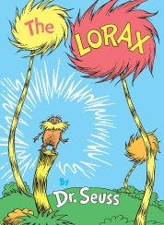 | The Rainbow Fish  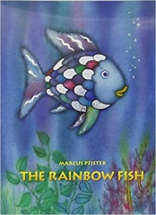 | Elmer  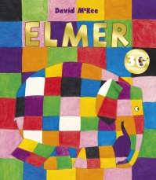 | Somebody Swallowed Stanley / A Planet Full of Plastic  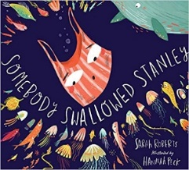  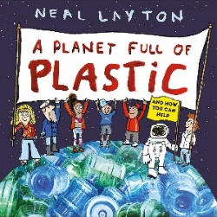 | No Dragons for Tea  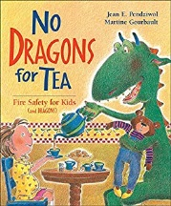 | The Mega Magic Teacher Swap  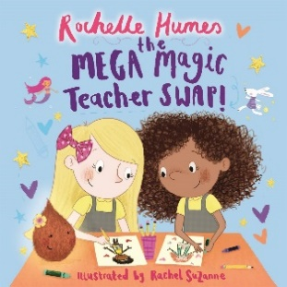
Year 1 | Autumn 1 | Autumn 2 | Spring 1 | Spring 2 | Summer 1 | Summer 2
 | ‘I can do it!’  All Things Green | ‘Who I am!’  Local area- Garston  Significant local events/people/places  Parts of human body  Then and Now | ‘Dinosaurs’  Animals including humans (classification)  Dinosaur Planet | ‘Fly me to the Moon!’  Moon  Moon Landing | ‘We are all special, we are all different!’  Weather/Climate Comparison | ‘Paralympics’  Equality  What Can You See?  Amazing
 | Wild  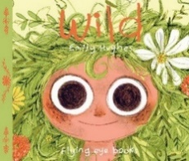  Rosie Revere Engineer  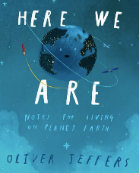  The Dot  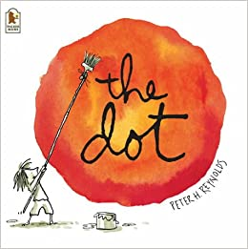 | Where’s My Teddy? (own experience)  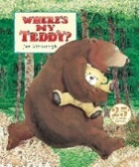  Bog Baby  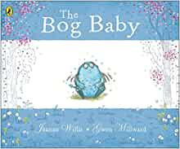  Tree  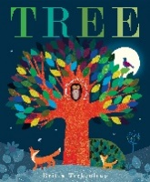 | Harry and the Bucketful of Dinosaurs  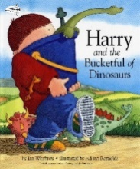  Prehistoric Actual Size  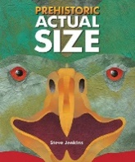 | Field Trip to the Moon  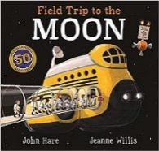  Beegu  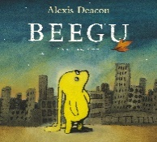  Toys in Space  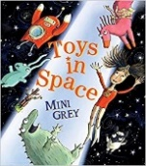 | Handa’s Surprise (predictable phrasing)  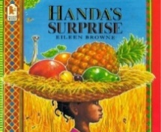  Ana Hibiscus  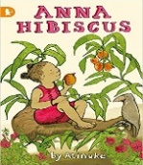  Amazing Grace  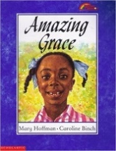 | The Ugly Duckling (fairy tale)  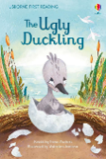  Avocado Baby  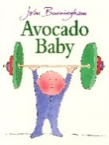  Lighthouse Keeper’s Lunch  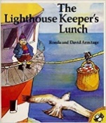
 | - Explanation text with diagrams.  - Poetry  - Retelling the story | - Retell story.  - Lists items needed to look after a Bog Baby.  - Instructions- how to care for Bog Baby.  - List poem about Seasons. | - Newspaper report about egg discovery in classroom  - Non-chronological report on a dinosaur  - Labels, captions for dinosaurs | - Non-chronological report: the moon landing  - Lists: what you need for space  - Diary entry | - Rhyming couplets  - 5 senses writing  - Cultural vocabulary  - Narrative: Write simple sentences using patterned language, words and phrases taken from the text. | - Captions/labels  - Sequence a story  - Diary: retelling traditional story from a character’s point of view  - character description
Year 2 | Autumn 1 | Autumn 2 | Spring 1 | Spring 2 | Summer 1 | Summer 2
 | ‘Mental Fitness’  PSHE- mental health and emotional well being  What a Wonderful World | ‘Wonderful Watford’  Watford- local area  The Great Fire Of London | ‘Arctic adventures’  living things and their habitats  Predators/food chains  Winter Wonderland | Space travel- rockets. Everyday materials & DT  Land Ahoy! | ‘Heroes’  Inspirational people from diverse backgrounds  Historical Heroes | DT- healthy eating  PSHE- what keeps me healthy? Keeping safe  Green Fingers
 | Just So Stories  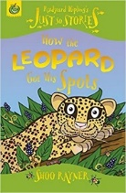  The Day the Crayons Quit  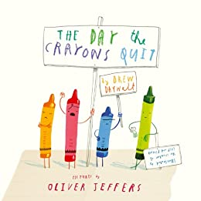  Ruby’s Worry  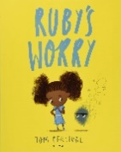 | Toby and the Great Fire of London  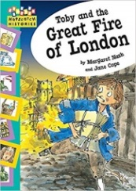  Charlie and the Great Fire of London  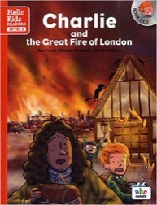 | Lost and Found  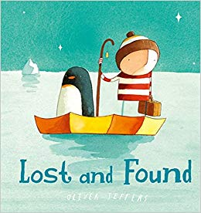  And Tango Makes Three  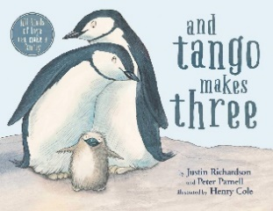 | The Pirates Next Door  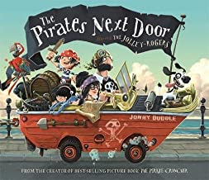 | Little People, Big Dreams:  Emmeline Pankhurst, Maya Angelou, Martin Luther King Jr, Rosa Parks, Stephen Hawking  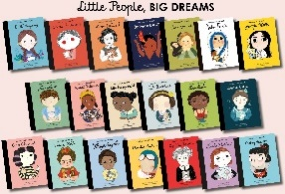  Counting on Katherine  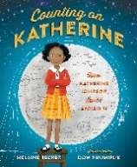 | Jack and the Beanstalk  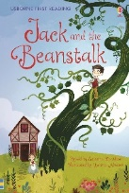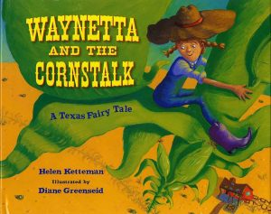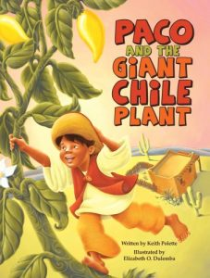
 | - Myths (creation story)  * * * * *  - Letters  - Information leaflet about a country  - Persuasive poster to visit a country  * * * * *  - Diary entry | - Instructions: fire safety, making bread  - Diary- Samuel Peeps  - Poetry- calligram  - Persuasive: selling a fire protecting invention | - Letter writing  - Narrative  - Non-Chronological Reports  - Other: poems, role play, hot seating, story maps | - Character description (wanted poster)  - Adventure story- space pirates  - Rhyming poems  - Explanation about how pirates steal a ship | - Poetry (acrostic)  - Non-chronological report about the life of an inspirational person  - Recount (diary) | - Narrative (retelling of traditional tale)  - Read different cultural versions and write their own version.
Year 3 | Autumn 1 | Autumn 2 | Spring 1 | Spring 2 | Summer 1 | Summer 2
 | ‘Ready, set, growth’ | Diocese | ‘Volcanoes’ | ‘Lightbulb moments’  Light | ‘People who’ve changed the world’  Artist/composers (a mix of modern and classic/ both genders/races etc)
 | Stone Age |  | Extreme Earth (Topic) | Bright Sparks (Science) | Maps and Orientation
 | Stone Age Boy  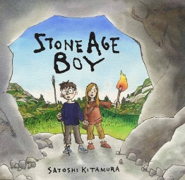 | Ug  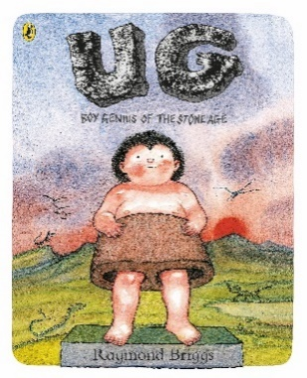 | The Firework Maker’s Daughter  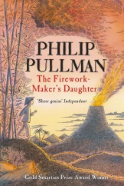 | The King who Banned the Dark  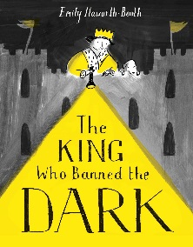 | The Great Kapok Tree (fables)  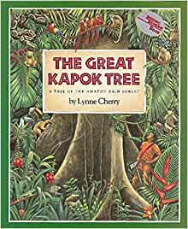 | The true story of the three little pigs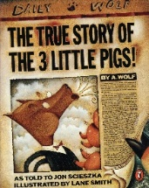  Honestly Red Riding Hood was Rotten!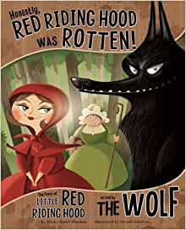
 | - Diary to sequence events  - Newspaper report  - Instructions- making a fire | - Setting description for opener for playscript  - Playscript writing  - * * * * *  - limericks | - Poetry (vocab & similes)  - Character description  - Narrative (adventure)  * * * * *  - Explanations- how volcanoes erupt | - Biography- Thomas Edison  * * * * *  - Poetry- rhyming couplets  - Persuasive writing in role as the king to the public | - Fables- write their own  - Poetry about the rainforest/ animals (haiku, tanka, kenning)  - Biography- David Attenborough | - Compare alternative fairy tales to originals  - Diary entry  - Character description  - Write their own for another known story
Year 4 | Autumn 1 | Autumn 2 | Spring 1 | Spring 2 | Summer 1 | Summer 2
 | ‘My strong mind’  Resilience | ‘Romans Rule!’  Hertfordshire-  Romans- St Albans | ‘The Indian sub-continent'  Living things and their habitats/ animals including humans | ‘Uncle Albert and friends'  Sound & electricity | ‘Challenging stereotypes’  The Proudest Blue
 | Romans |  | Water | The Vikings | The UK
 | Roman Invasion  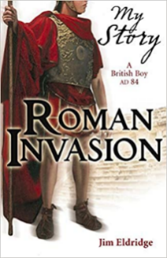  Empire's End - A Roman Story  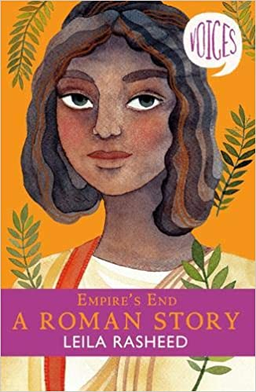 | Escape From Pompeii  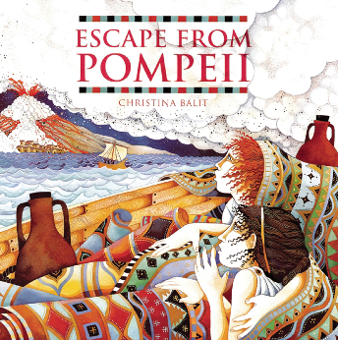 | The Rhythm of the Rain  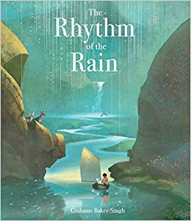 | Norse Myths  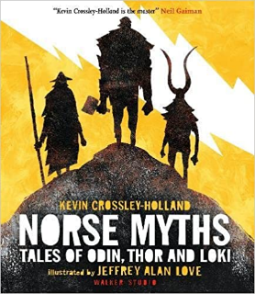 | Bills New Frock  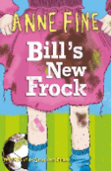  Boy in the Dress  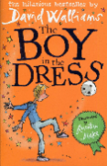  My Princess Boy  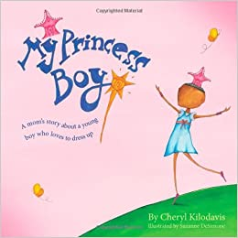 | The Story of London  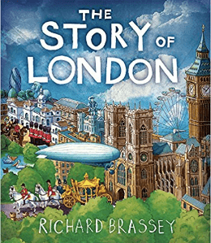
 | - Non-chronological report on a Roman soldier  - diary entry for Camilla | - setting as the introduction for a play  - write a playscript based on the book | - poetry (vocab building- about the Ganges)  - setting description (link to India)  - explanation of the water cycle | - myths  - Riddles about Norse Gods | - story with a theme (stereotypes)  - discussion: make links between wider stereotypes and British Values. Is this fair? | - persuasive letter writing: why should this British town/city be the new capital?  - narrative poetry: what was on the site of the school before it was a school?
Year 5 | Autumn 1 | Autumn 2 | Spring 1 | Spring 2 | Summer 1 | Summer 2
 | ‘The Power of yet!’ | ‘London calling’ | ‘Stewards of creation’  Living things and their habitats/ animals including humans | ‘The Solar System’  Earth/Moon/stars  Gravity & forces | ‘People who dare to be different’
 | Geographical Skills / Changes Over Time |  | Ancient Greece |  | Egypt
 | Zoo  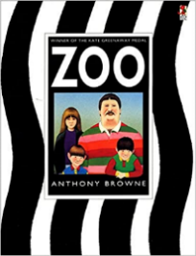  Don’t touch my hair  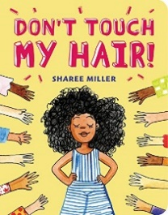 | The London Eye Mystery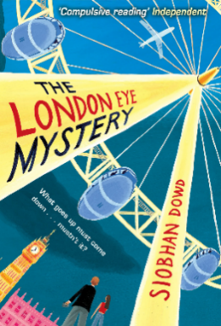 | The Secret Garden  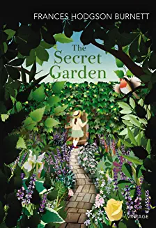 | Heroes of the Night Sky  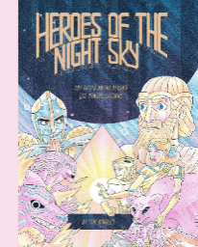  The Legend of Heracles  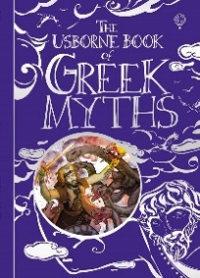 | The Secrets of Tutankhamun  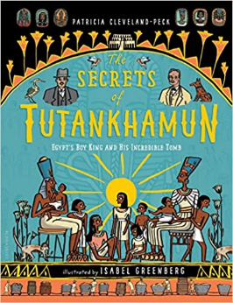 | So You Think You’ve Got It Bad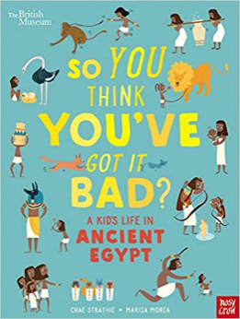
 | - Persuasion about closing zoos  - rap from the point of view of an animal in a zoo  - Persuasion about consent | - Suspense and mystery story | - Fiction from our literary heritage  - cinquain poems about the garden | - Design a constellation and write the myth  - instructions: how to become a hero  * * * * *  - The difference between myths and legends. In Heracles, What is likely real/myth?  * * * * *  - explanation: Ancient Greek advancements on our knowledge of the solar system | - Discussion: is it right to disturb settlements and excavate?  - Biography of a significant Pharaoh/explorer e.g.  Hatshepsut, Cleopatra, Ramses the Great, Champollion, Howard Carter etc. | - Explanation about mummification process  - Non-Chronological report- Egypt link
Year 6 | Autumn 1 | Autumn 2 | Spring 1 | Spring 2 | Summer 1 | Summer 2
 | ‘Managing your mind!’ | ‘Changing Britain’  Politics/BAME | ‘Africa is not a Country’ | ‘The Big Bang Theory’  Evolution/inheritance/adaptation  Electricity Uncle Albert | ‘Race cars’  Black Lives Matter | Animals including humans- Circulatory/ Respiratory system
 | WWII |  | The Mayans |  | North America
 | Spiderwick Chronicles  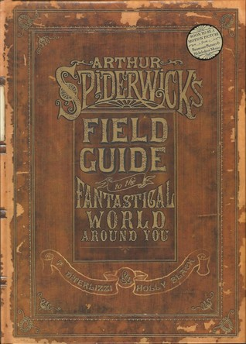 | Rose Blanche  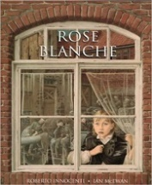  Now or Never  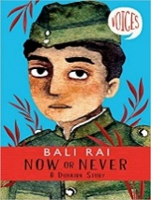  War Poetry  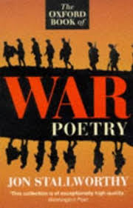 | Journey to Jo’burg  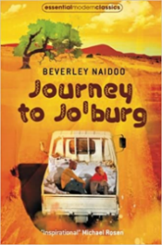  The Popol Vuh  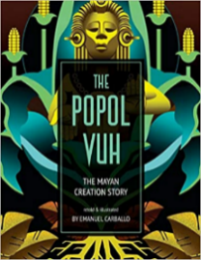 | Middleworld  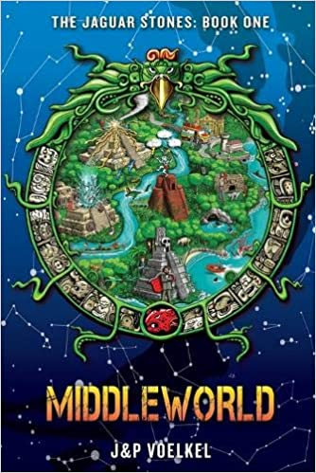 | Holes  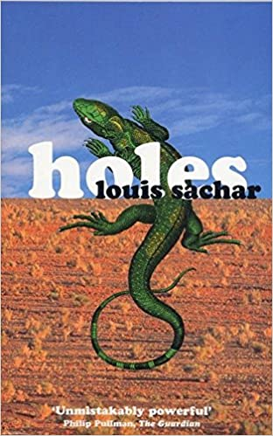 | Pig Heart Boy  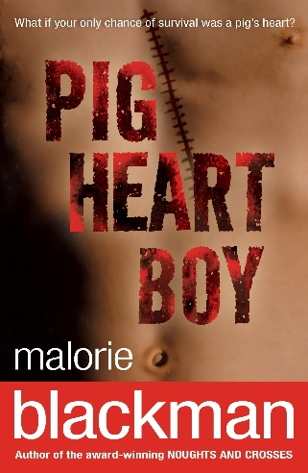
 | - report writing  - poetry (vocabulary/imagery) | - war poetry  - descriptive writing  - recount (diary) of Rose Blanche/soldier  - discussion:  1) Winston Churchill had the hardest job as Prime Minister.  2) Winston Churchill was a great man. | -Discussion text (segregation)  * * * * *  - explanations  Maya culture  - recount of the creation story (newspaper report) | - Writing in different fiction genres  * * * * *  - Recount- Charles Darwin journals | - narrative with a flashback  - Persuasion  - complaint letter  - debate: BLM linked to Holes sequel (Small Steps) | - Debate  - Explanation- how the heart works  - Recount- diary entry  - monologue

