St Catherine of Siena Marking & Feedback Policy

Aims
The purpose of marking and feedback is to:
1) show children that we value their work, encourage them to do the same and celebrate their achievements;
2) let pupils know the extent to which they have met the learning intention and success criteria;
3) evidence clearly how far children have come in their learning journey and clarify what their next steps are;
5) promote self-assessment and self-editing, whereby pupils critically evaluate their own learning and are proactive in improving their work;
6) promote peer-assessment, whereby children collaborate to evaluate and improve the work of others and thereby enhance their ability to evaluate their own work;
7) provide a basis both for summative and formative assessment;
8) provide on-going assessment, which informs future lesson-planning; and
9) demonstrate clear, measurable progress and individual/class attainment against national age related expectations.

Marking & Feedback Cycle

English

Success Criteria Stickers – Steps to Success - (“S2S”)

S2S are stuck into a child’s book at the start of a unit. These match the text types and are differentiated to take into account a child’s prior learning and attainment. The majority of a class should be using the S2S for their year group’s ARE, (e.g. most Year 4 pupils should be using LKS2 B or A). However, lower attaining, higher attaining or SEN pupils should be provided with the S2S which best fit the correct level of challenge for them. Opportunity should be provided throughout the unit of work for children to progress to a higher S2S if they are working on a sticker lower than their ARE.

Before pupils begin a writing task (ideally while looking at high quality texts at the start of a unit), the teacher will go through the S2S Sticker with the class to ensure:
- all technical and grammatical vocabulary is understood;
- children are able to find examples of each success criteria point within the texts they are examining; and
- they have an oversight of the ‘big picture’ – where they should be by the end of their learning journey in that unit.

Throughout teaching, the S2S will be referred to as appropriate.

Self & Peer Assessment

After each piece of extended writing, pupils will be given the opportunity to self and peer assess. They tick (achieved) or cross (not achieved) or colour in for KS1 C against the S2S (See Appendix A). Children will be encouraged to go back and improve their work, taking into account anything that they, or their partner, have identified is missing from their work, e.g. putting in missing fronted adverbials.
As part of self and peer assessment, strengths and next steps (relating to S2S) will be explicitly referred to in a summative statement below the piece of writing. This helps the children to self-reflect at each step of the learning process.

Examples of self and peer assessment:
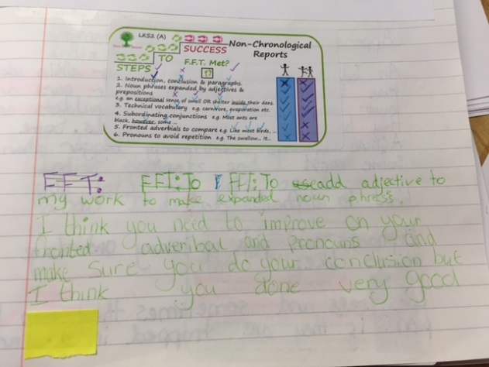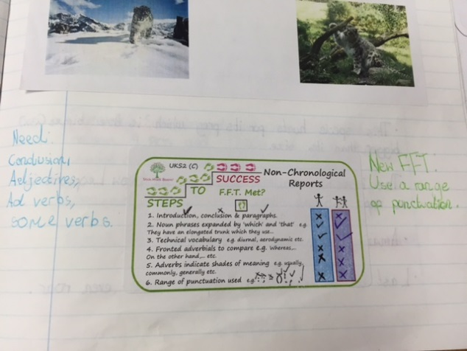

Adult Marking

On some pieces of writing, quality self & peer assessment (along with whole class verbal feedback), will be sufficient to enable children to take the next steps. Therefore, adult marking will be unnecessary.

When adult marking does take place, it will be using pink and green, against the S2S.

Pink = ‘Tickled Pink’ for strength.

Green = ‘Green for Growth’ for areas for development.

Whilst reading a child’s work, an adult will highlight their writing, using pink and green and also highlight the S2S to indicate success against the success criteria. Where a child has not achieved one of the steps, this will be highlighted green. The child knows that this is their Next Step – to turn their pink into a green. Where possible, the adult marking will indicate, (e.g. using the number of the step), where the child has failed to meet this Step so that the feedback is as specific as possible.

If a child has met a Step, but not consistently, this may be dotted in pink.

It is an expectation that pupils will respond to the adult marking by improving their own work

Marking against the Learning Objective will using the ‘three tick’ system:

One tick = IAL not met

Two ticks = IAL met

Three ticks = IAL exceeded

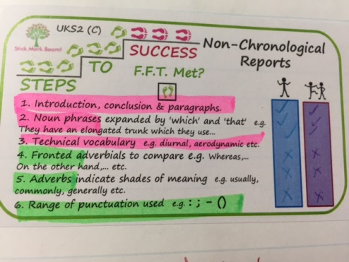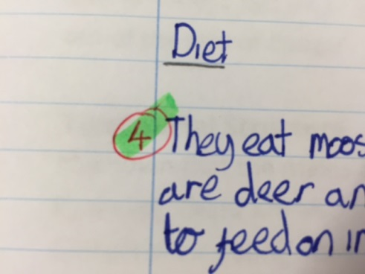

Where applicable, children may write their Feedback Friday Target in the margin of their work to remind them to focus on this. It is also a visual reminder for the adult marking of what their personal FFT is.

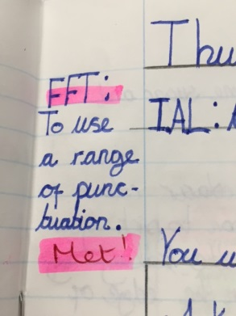

Guidance for adults providing marking and feedback

All marking should be constructive and positive, enabling children to celebrate their successes, while guiding them as to their next steps. Adults will use their judgement when highlighting the S2S to ensure that a child is not demoralised (e.g. if too many steps are unmet, they may only highlight two). Similarly, if the nature of the piece of writing is such that all the steps could not be met (e.g. where the children were only asked to write the beginning of a piece), then steps which are not applicable will just be left blank. Teachers should use their professional judgement if an obvious target is required which is not directly in the success criteria.

Since the S2S provide the developmental/constructive feedback, written comments should be short and praise based.

In addition to marking against the IAL and using green and pink, adults may set up to three spellings. Identified spellings should be either high frequency words, or subject specific technical vocabulary. Children will re-write the spelling correctly three times.

Who marks?
Any adult that works with the children may mark work. Teachers mark in red, Teaching Assistants or student teachers mark in green.

Does every piece of work need to be marked?
No. Provided that children are taught and guided as to how to self and peer assess well, this will be sufficient for some pieces. Additionally, verbal feedback may be given to the whole class, a group of pupils or an individual.
Maths
Maths Map Cover Targets
At the start of each unit of learning, pupils will refer to the Cover Targets to identify which learning objectives they will be working on.
Children will only write on the left side of the page in a single column, so that teacher feedback and corrections can be done on the right of the page.
Teachers or children will mark their work using ticks or crosses/dots. Pink and green will be used to highlight successes and areas for development in pupils’ books.

Self & Peer Assessment

In KS2, Pupils will regularly be given the opportunity to self and peer assess. They will review their progress towards achieving the Cover Target they are working on. As part of self and peer assessment, strengths and next steps will be explicitly referred to. Children will be encouraged to use metacognition principles to reflect on their own learning and record this in a summative statement below their work, e.g. “ I am able to multiply 4-digit numbers by 2-digit numbers. I made mistakes when I forgot to put a zero as a placeholder. My next step is to apply this to word problems.” This helps the children to self-reflect at each step of the learning process.
Next Step Questions
NSQs may be used in several ways.
- Where a Cover Target has been identified and set as an FFT, the NSQ Sticker may be stuck in before a strand is taught, so that the child knows what they are trying to achieve by the end of that teaching ‘block’. Once the unit has been taught, the child should go back and complete the NSQ to demonstrate that they have taken their Next Step. A new FFT can then be set from the next strand.
- To monitor progress against Age Related Expectations, a NSQ can be set as a summative task at the end of a lesson or the unit as part of a plenary (like Pitch & Expectations questions).
- Where a child has achieved an objective from their year’s ARE, a NSQs from the same strand, but from a higher year may be included as part of the teacher’s marking. When the strand is revisited, the pupil can then attempt to take their Next Step.
Once a NSQ has been successfully answered, the child may colour in the corresponding Cover Target, using a pink pencil. As each block is taught for the final time in a year, the teacher may highlight the Cover Targets in pink or green as a form of summative assessment. This can then inform the following teacher’s planning.
Reviewed by: SLT
Date: June 2023
Next review: June 2025

